

**“Network Project “**

**Team Members**

**Amr Hussien Ahmed 20172025**

**Mahmoud Ahmed Khalifa 20173172**

**Abdallah elsayed attlam 20173317**

**Amr Hesham 20171694**

**Mohamed Essam 20170492**

**Dr/ Shimaa Saad.**

**TA/ Mariem Ali.**

**Project : Game called “Escape”.**

**Description :**

**This game that in local host in two packages in “netbeans”,**

**One of this packages is a client and the other is server ,**

**In the one package (Client), When the character start to move and shock in the wall, Should be appear a frame that called “Loser” and in the other Package (Server) will stop and appear this frame also in it .**

**And this work by TCP (Persistence) because we need to open one tap connection and make all actions and requisites and responses in this tap connection.**

**Screen Shoots To running and listening actions in server :**

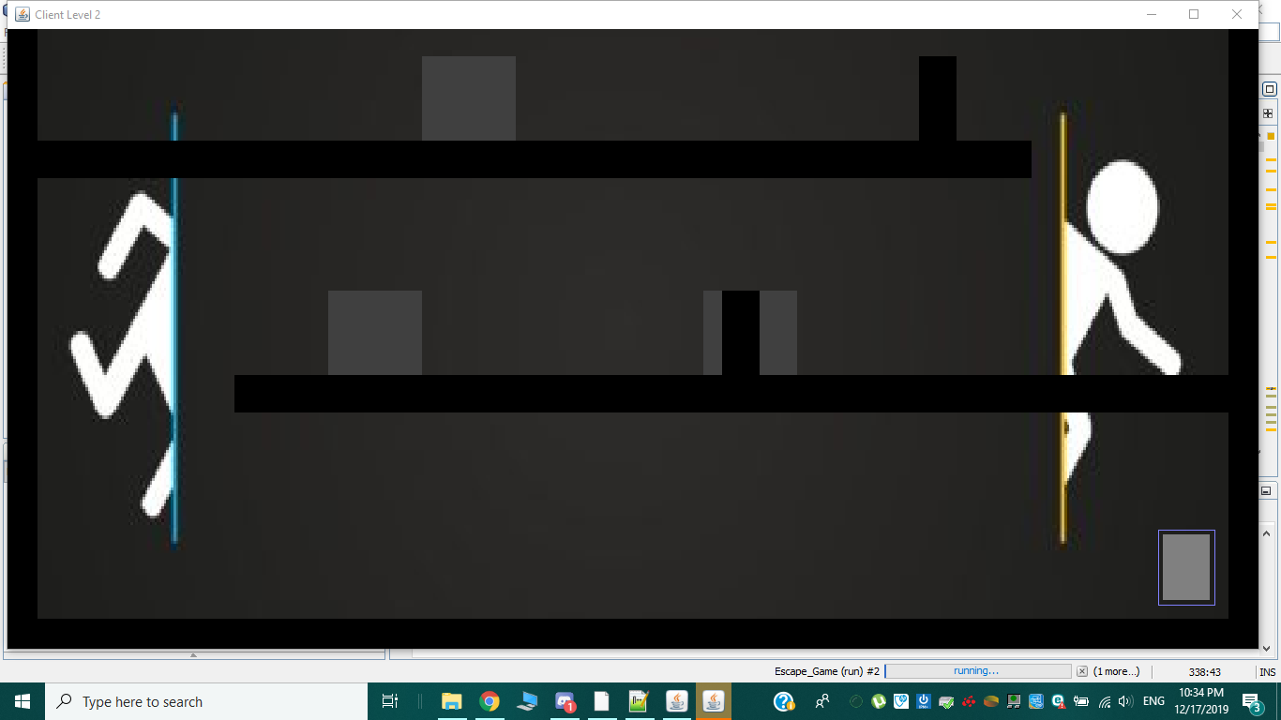

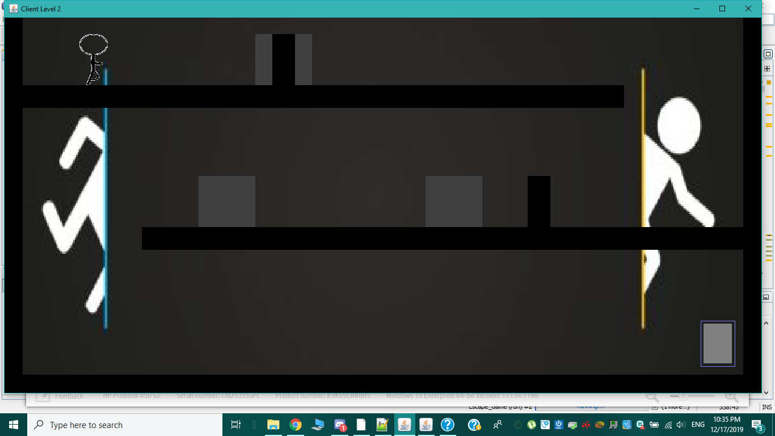

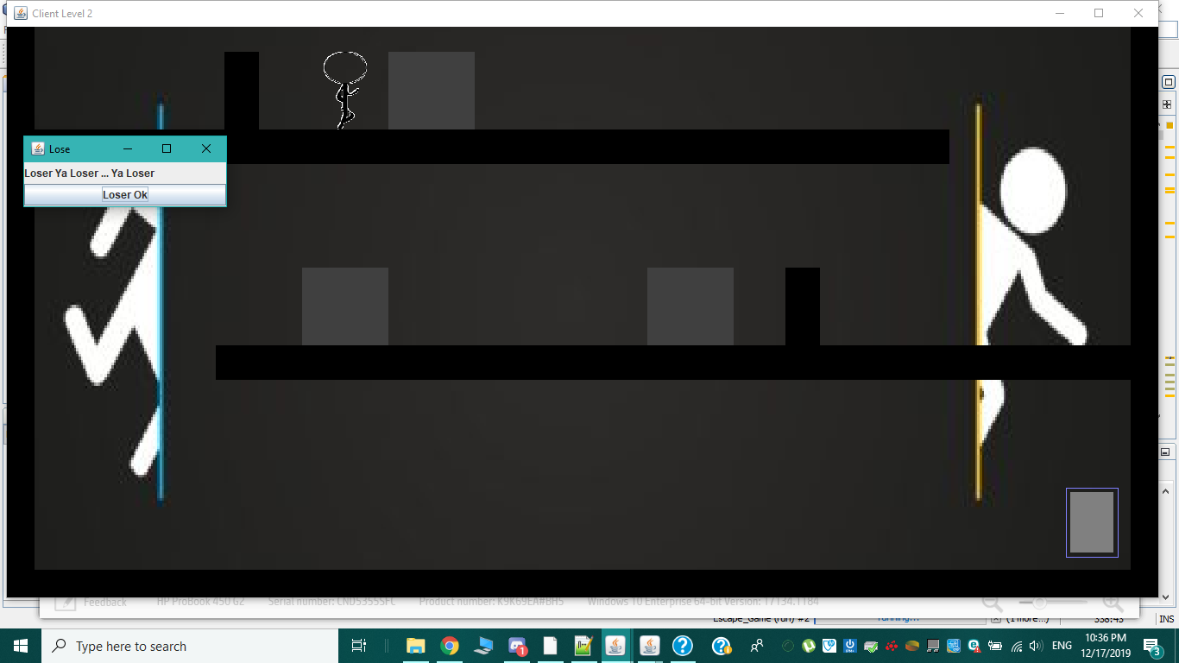

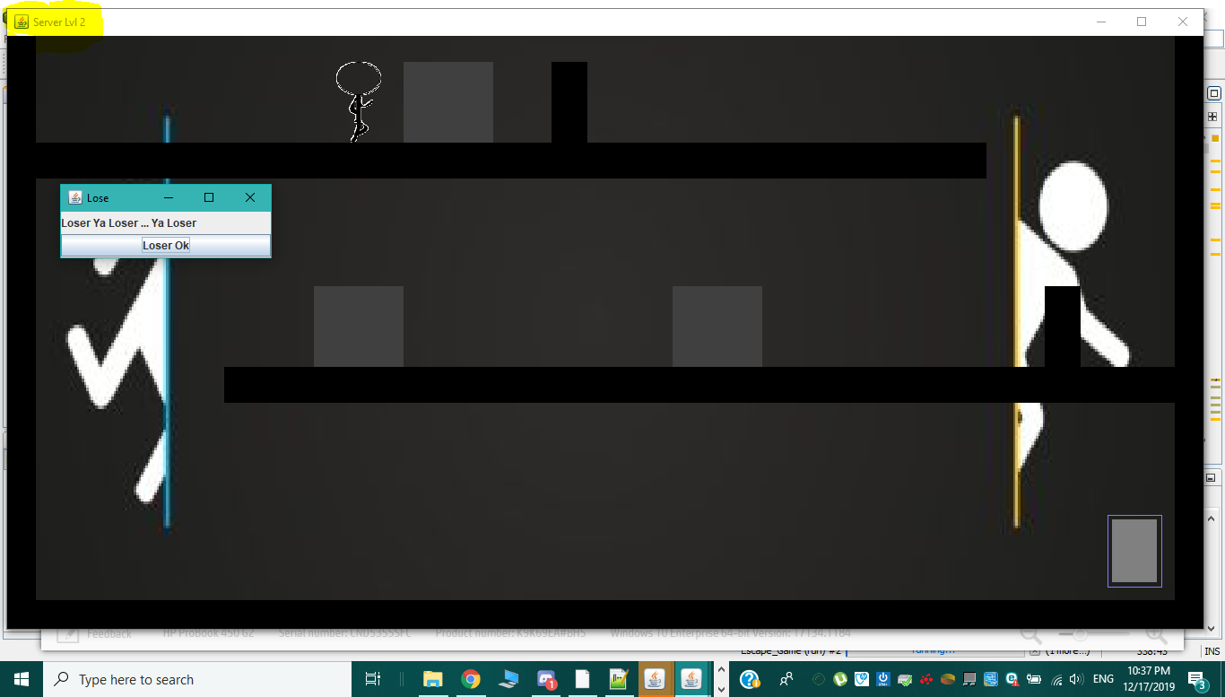

**\*\*Finish\*\***